Module: SQL Views (Virtual Tables)
1. Fundamentals: What is a View?
- Definition: A View is a virtual table. It is not a physical object that stores data; instead, it is a stored SQL query (persisted logic) that lives in the database.
- The Metaphor: Think of a View as a permanent "Custom Lens" placed over your physical database.
  - The physical tables are the actual objects in the room.
  - The View is a lens that might blur out sensitive details (Security), filter only green objects (Row-Level Security), or rearrange messy objects into a neat row (Abstraction).
- How it Works: When you query a view, the SQL engine grabs the stored query logic from the view definition and runs it against the underlying physical tables to get fresh data.
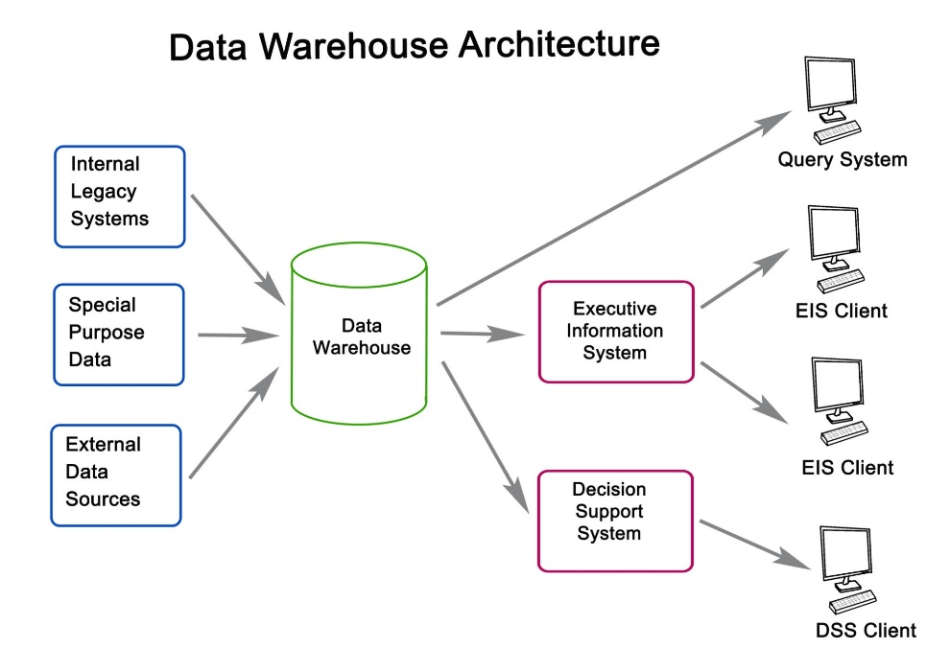

2. Comparison: Views vs. Tables vs. CTEs
Feature | Physical Table | View (Virtual Table) | CTE (Common Table Expression)
Data Storage | Stores actual data files. | Stores no data (only logic). | Stores no data (temporary result).
Persistence | Permanent. | Permanent logic. | Temporary (exists only during 1 query).
Performance | Fastest (Direct access). | Slower (Runs a query to get data). | Fast (Memory-based).
Primary Use | The single source of truth. | Reusable logic & Security. | Complex logic breakdown for one-time use.
Maintenance | Hard to change structure. | Easy to update (just change the query). | Zero maintenance (disappears after use).

3. MySQL Syntax (DDL Commands)
This is where MySQL differs slightly from SQL Server. MySQL makes updating views much easier.
A. Creating a View
- Syntax:
CREATE VIEW view_name AS
SELECT column1, column2
FROM table_name
WHERE condition;
B. Updating a View (The MySQL Advantage)
- SQL Server Method: You usually have to DROP the view first, then CREATE it again.
- MySQL Method: You can use a single command to overwrite the existing logic.
- Syntax:
CREATE OR REPLACE VIEW view_name AS
SELECT new_column1, new_column2 ...
C. Deleting a View
- Syntax: DROP VIEW view_name;

4. Core Use Cases (Why use Views?)
- Centralize Business Logic:
  - Problem: You have a complex query (joining 5 tables) that 10 different analysts use. If the logic changes, you have to tell 10 people to update their scripts.
  - Solution: Create a View. If logic changes, update the View once, and everyone gets the new logic automatically.
- Implement Security (Data Protection):
  - Column-Level Security: You can create a view that selects Employee_Name but excludes Salary. Users with access only to the view cannot see the salary.
  - Row-Level Security: You can create a view with a WHERE Country = 'USA' clause. Users of this view will never see data from Europe.
- Abstraction (Hiding Complexity):
  - You can rename cryptic column names (col_x_99) to friendly names (Customer_Name) inside the view, making the database easier for non-technical users (like Power BI analysts) to understand.

Example Scenario: The "Safe" Employee List
Goal: Create a reusable data source for the HR Intern. They need to see active employees and their full names, but must not see salaries or inactive employees.
-- 1. Create the View (Logic + Security)
CREATE OR REPLACE VIEW v_active_directory AS
SELECT
employee_id,
-- Abstraction: Combine names and rename column
CONCAT(first_name, ' ', last_name) AS full_name,
department,
email
FROM employees
WHERE status = 'Active'; -- Row-Level Security

-- 2. The Intern's Query (Simple & Safe)
SELECT * FROM v_active_directory;
-- Result: They see names/emails, but NO salaries and NO inactive staff.

Quick Recap
- View = Saved Query. It stores logic, not data.
- MySQL Syntax: Use CREATE OR REPLACE VIEW to easily update logic.
- Security: Use Views to hide sensitive columns or filter out sensitive rows.
- Abstraction: Use Views to rename messy columns into friendly business terms.

